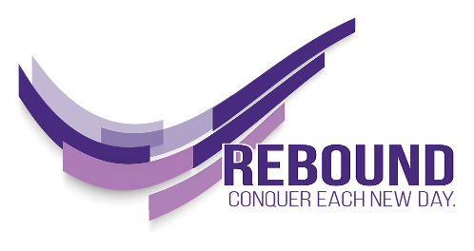

WHAT’S YOUR REBOUND STORY?
When we share our story, we take what was once in the darkness and expose it to the light. We create a lighthouse for others to find safety and comfort in knowing they are not alone.
Please consider sharing your own Rebound story. Your story can help others not feel alone. Sharing our stories helps us all learn and grow together.
Be as creative as you want. Some of the prompts below may help you get started. You can share your video on the Rebound Facebook page (JMU Rebound) and send it to the Dean of Students to share on the Rebound web page (www.jmu.edu/rebound).
There is no right way to do this; it’s your story. The only thing we suggest: Turn your device to landscape so that your video is horizontal.
POTENTIAL PROMPTS
- Tell the story of what happened that led to your setback or failure?
- How did you initially feel after the setback?
- What did you say about yourself after the failure or setback (what was your self-talk)?
- What harm was caused to yourself by the setback?
- What harm was caused to others by your setback?
- What did you do to take care of yourself after the setback? Were there any resources that you used to help you recover? (If this was JMU related, what JMU resources helped?)
- What did you do to make things right or as right as possible, to fix as much as possible from your failure?
- What did you learn about yourself in the process?
- How are you better because of the experience?
- How did you learn and grow from your setback?
- Was there anything you changed about yourself, your habits, or your behavior because of the setback?

