Lesson Plan : Light
This lesson plan is intended to be a guide to see how a demonstration might fit in to the lesson, information wise. This lesson plan does not contain the modes of how to teach, rather a suggested outline of information.
Students will:
- know the wave nature of light
- know the particle nature of light
- manipulate the equation c = λν
- manipulate the equation E_{photon} = hν
Background Knowledge Assumed
- students can manipulate: moles = mass/molecular mass
- students can manipulate: moles = atoms/Avogadro’s number
- students can convert metric units
Lesson
- First, let’s talk about how light acts as a wave. All waves have a frequency, (ν), the number of cycles a wave has per second. This is measured in Hertz (1/s). Waves also have a wavelength, (λ), which is how long the wave is. This is measured from the top of one wave to the top of another (or bottom to bottom), and it is usually measured in nm or another small unit. The product of frequency times wavelength is always a constant, it comes out to be the speed of light (3.00 x 10⁸ m/s). Wavelength should always be converted to meters. This relationship qualitatively means that if a wave has a high frequency it has a short wavelength. Equation: c = λν.
- The light that we see is just one type of electromagnetic radiation. There are other types of waves with longer or shorter wavelengths than visible light. Some of these include X-rays, microwaves, and radio waves. (See chart) The different colors of light that we see have different wavelengths, for instance red is in the ~680-750nm region.
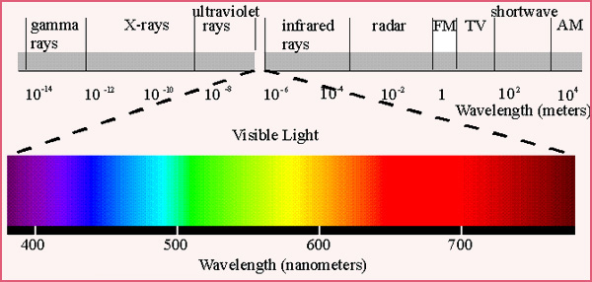
- Light also has characteristics of a particle. Maxwell Planck noticed that when some objects are heated, they give off (emit) light (think of a red hot coal). He came up with the idea that the light energy was emitted in packets; it wasn’t a continuous flow of energy, but rather energy was released one quantum at a time. A packet of light is called a photon. Each atom can absorb or emit one photon. The energy of one photon is equal to Planck’s constant (h = 6.626 x 10⁻³⁴ J*s) times the frequency of the light. Equation: E_{photon} = hν
- Since each atom can emit or absorb one photon we can find the number of photons in a sample by using moles and Avogadro’s number.
- The instructor points out that from c = λν, ν = c/λ. This can be inserted into E_{photon} = hν to give: E_{photon} = hc/λ
- The instructor does the demo “Colored Flames”. The instructor explains that the reason they see different colors of light in the ethanol flames is because the salts that are being heated give off radiation in the form of visible light. Typically the colors result from a different metal in the salt being burned, and this is how fireworks get their colors.

There is a problem set to go along with this demonstration as well (under “Colored Flames” on the website)

