Blue Bottle Demo
DESCRIPTION:
Under basic conditions glucose is oxidized while methylene blue is reduced, changing from blue to colorless. Shaking the flask which forces oxygen into solution, which re-oxidizes the reduced dye back to its blue form. As the flask sits, the methylene blue oxidizes more glucose, thus being reduced and losing its color again. The cycle can be repeated until all of the glucose has been oxidized or until the oxygen in the flask is depleted.
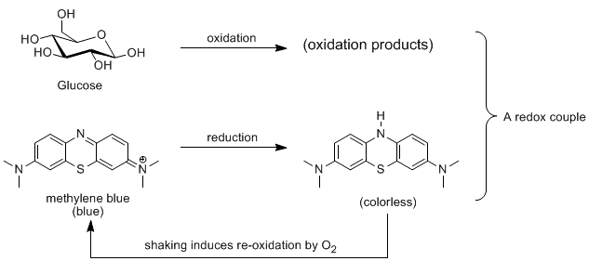
TOPICS COVERED:
- redox
- indicators
- organic reactions
- color change
- chemical change
MATERIALS NEEDED:
- KOH
- glucose
- 1% methylene blue solution
- water
- 125mL Erlenmeyer flask
- stopper
- parafilm
- beaker
- graduated cylinder
PROCEDURE:
1. Dissolve 4g of KOH into 40mL of water in the beaker
2. Dissolve 4g of glucose into 40mL of water in the flask
3. Add 2-4 drops of methylene blue to the flask
4. Pour the KOH solution into the flask
5. Stopper and wrap parafilm around the stopper
6. Wait for the solution to go clear, then shake
ADDITIONAL COMMENTS:
This is a great one to prep ahead of time, then take to lecture. The flask should last for a few shakes.
SAFETY:
Safety goggles should be worn at all times. KOH is caustic and can cause burns.
REFERENCES:
Shakhashiri, B.Z. Chemical Demonstrations; University of Wisconsin Press: Madison, 1985; Vol. 2, pp 142.
"Blue Bottle Experiment." Union College Chemistry. Accessed 4 July 2010. <http://www.union.edu/academic_depts/chemistry/faculty/fox/Chemical%20
Demonstrations/docs/10%20Blue%20Bottle.pdf>.

